DNS over TLS (DoT)

What is DNS over TLS (DoT)?
# Source: AI Source: Provided by: [Data Path: Persons Table -> ID Column: 1, Name_En Column: Motasem Essam] -> From: [ChatGPT] on [1/18/2026]
DNS over TLS (DoT) is a security protocol that encrypts Domain Name System (DNS) queries using Transport Layer Security (TLS).
Its main purpose is to protect DNS traffic from eavesdropping, tampering, and manipulation by encrypting communication between a client (such as a device or router) and a DNS resolver.
Normally, DNS queries are sent in plain text, which allows attackers, ISPs, or network operators to see which websites users visit. DoT prevents this by encrypting DNS queries and responses.

How It Works
# Source: AI Source: Provided by: [Data Path: Persons Table -> ID Column: 1, Name_En Column: Motasem Essam] -> From: [ChatGPT] on [1/18/2026]
- Client initiates a connection to a DNS resolver using TLS.
- The connection is made over TCP port 853 (the standard port for DoT).
- A TLS handshake occurs to establish a secure, encrypted channel.
- DNS queries are sent through this encrypted tunnel.
- The resolver processes the query and sends back the encrypted response.
- The secure connection can be reused for multiple DNS queries.
This process ensures:
- Confidentiality of DNS queries
- Integrity of DNS responses
- Authentication of the DNS resolver

DoT vs DoH (DNS over HTTPS)
# Source: AI Source: Provided by: [Data Path: Persons Table -> ID Column: 1, Name_En Column: Motasem Essam] -> From: [ChatGPT] on [1/18/2026]
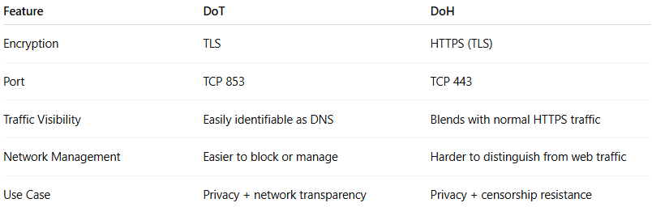
Feature | DoT | DoH
Encryption | TLS | HTTPS (TLS)
Port | TCP 853 | TCP 443
Traffic Visibility | Easily identifiable as DNS | Blends with normal HTTPS traffic
Network Management | Easier to block or manage | Harder to distinguish from web traffic
Use Case | Privacy + network transparency | Privacy + censorship resistance
Key difference:
- DoT is specifically for DNS and is more transparent to network administrators.
- DoH hides DNS traffic inside HTTPS, making it harder to monitor or filter.

Examples of DoT Providers
# Source: AI Source: Provided by: [Data Path: Persons Table -> ID Column: 1, Name_En Column: Motasem Essam] -> From: [ChatGPT] on [1/18/2026]
Here are well-known public DNS providers that support DoT:
- Cloudflare
  - Server: 1.1.1.1
  - Hostname: cloudflare-dns.com
- Google Public DNS
  - Server: 8.8.8.8
  - Hostname: dns.google
- Quad9
  - Server: 9.9.9.9
  - Hostname: dns.quad9.net
- AdGuard DNS
  - Server: 94.140.14.14
  - Hostname: dns.adguard.com

Who Supports DoT?
# Source: AI Source: Provided by: [Data Path: Persons Table -> ID Column: 1, Name_En Column: Motasem Essam] -> From: [ChatGPT] on [1/18/2026]
Operating Systems
- Android (Android 9+ via “Private DNS”)
- Linux (systemd-resolved, Unbound)
- Windows (Windows 11, limited Windows 10 support)
- macOS (via third-party tools)
Browsers
- Firefox (via system or custom settings)
- Chrome/Edge (via OS-level DoT)
Networking Devices
- Routers (OpenWRT, pfSense, OPNsense)
- Firewalls and enterprise DNS resolvers
DNS Software
- Unbound
- Knot Resolver
- BIND (experimental/limited)

Summary
# Source: AI Source: Provided by: [Data Path: Persons Table -> ID Column: 1, Name_En Column: Motasem Essam] -> From: [ChatGPT] on [1/18/2026]
- DNS over TLS (DoT) encrypts DNS queries using TLS to improve privacy and security.
- It uses TCP port 853 and establishes a dedicated encrypted DNS channel.
- Compared to DoH, DoT is more transparent and easier to manage in networks.
- Many major DNS providers and modern operating systems support DoT.
- DoT is ideal for users who want strong DNS privacy without disguising DNS traffic as web traffic.
If you’d like, I can also provide configuration examples, security advantages vs DNSSEC, or real-world use cases.

